The Title Goes Here with Each Initial Letter Capitalized
(Use template style Paper Title or Times New Roman, 18 pt, bold, centered.)
Author’s Name^{1, a)} and Author’s Name^{2, 3, b)}
(Use template style Author Name or Times New Roman 14 pt, centered. Names should be written First Name Surname.)
¹Replace this text with an author’s affiliation
²Additional affiliations should be indicated by
superscript numbers 2, 3, etc. as shown.
³Multiple affiliations for the same author are listed separately
(Use complete addresses, including country name or code. If authors share an affiliation, list the affiliation once and number accordingly. If there is only one affiliation for all authors, the association is not needed.
Use template style Author Affiliation or Times New Roman 10 pt, italic, centered.)
^{a)} Corresponding author: your@emailaddress.xxx
^{b)}anotherauthor@thisaddress.yyy
(Use superscript “a)” to indicate the corresponding author’s email address. If you want to include email addresses for additional authors, use b), c), etc. Use template style Author Email or Times New Roman 10 pt, italic, centered.)
Abstract. To format your abstract, use template style Abstract or Times New Roman 9 pt, justified. Each paper must include an abstract. Begin the abstract with the word “Abstract” followed by a period in bold font, and then continue with a normal 9-point font.

HOW TO USE THIS TEMPLATE
(For Level I headings, use template style Heading 1 or use Times New Roman12 pt, bold, ALL CAPS, centered.)
This document is the JURPA manuscript template for Microsoft Word. It provides a simple example of a paper and offers guidelines for preparing your article. To format a normal paragraph, like this one, use template style Paragraph or Times New Roman 10 pt, indent: first line: 0.2", justified. To reference source material, use brackets [1] or superscript numerals.¹ In both cases the reference should be placed after the period.[1] Here is an example with superscript formatting.¹
You can edit or delete the content provided in this template and replace it with that of your article, but please read through the text first. Be sure you do not accidentally leave any of this text in your paper!

How to Apply the AIP Conference Proceedings Template Paragraph Styles
(For Level II headings, use template style Heading 2 or use Times New Roman, 12 pt, bold, centered.)
We have made template styles in this file for you. To apply a template style, first make sure you are in the “home” tab in MS Word. Find the “Styles” widget. Click the arrow icon in the bottom right to open the styles window. Then select and apply the appropriate style. To apply a style to a paragraph, click anywhere in the paragraph, then select the appropriate style from the list.

First, Second, and Third Level Headings
There are three levels of heading styles: Level I, Level II, and Level III. The first time a heading style appears, we let you know the style details. The main sections in your paper should be Level I. Level I headings are in ALL CAPS.

Level 2 Heading with Each Initial Letter Capitalized
Words in second and third level headings should have their initial letters in uppercase except for prepositions (of, for, from, with, in, off) and articles (an, a, the). If a preposition or article is the first word in the title, it should be capitalized.

Level 3 Heading with Each Initial Letter Capitalized
(For Level III headings, use template style Heading 3 or use Times New Roman 10 pt, italic, centered)
Level 3 headings may not be necessary, but are available if you need them.

MATHEMATICS
Here we provide some basic advice for formatting equations, but we do not attempt to define detailed styles or specifications for typesetting. You should use the standard styles, symbols, and conventions for the discipline you are writing about.
Cite all equations in consecutive order. The word “Equation” should be spelled out if it is the first word of the sentence and abbreviated as “Eq.” elsewhere in the text. If you are writing about an equation, please refer to it by number, like this: Eq. (1). Add a period after your equation if it completes a sentence.

Formatting and Inserting Equations
Equations should be added using the Insert - Equation feature in Microsoft Word. Equations should be centered with equation numbers in parentheses on the right-hand side (flush right). Achieving a pleasing layout of equations can be tricky in Microsoft Word, so here is one way to do it.

- Insert your equation on a new line.
- To add an equation number, click the space to the right of the equation and, from the “References” tab select “Insert Caption.”
- Click on “New Label” and type the left parenthesis “(“ then click “ok.”
- The caption name should now read “(1”. Add the right parenthesis and click “ok.”
- Right align the caption.
- Place your cursor between the equation and caption and click “tab” until the equation is centered.
- Adjust font formatting if necessary.

Note that you most likely will not need to repeat steps 3 and 4 for every equation number; the “(“ label should auto populate and increase in value each time.

${\left(x+a\right)}^{n}=\sum_{k=0}^{n}{\left({n \atop k}\right)x^{k}a^{n-k}}$ ( 1)

FIGURES AND TABLES

Figures, tables, and equations must be inserted in the text and may not be grouped at the end of the paper.

Figures
If you need to arrange figures, placing them in a table gives you additional control of the layout. Leave a line space between your figure and any text above it, and the figure description and any text below it, like this one. If you have two figures next to each other, one should be labeled (a) and one should be labeled (b) as below.

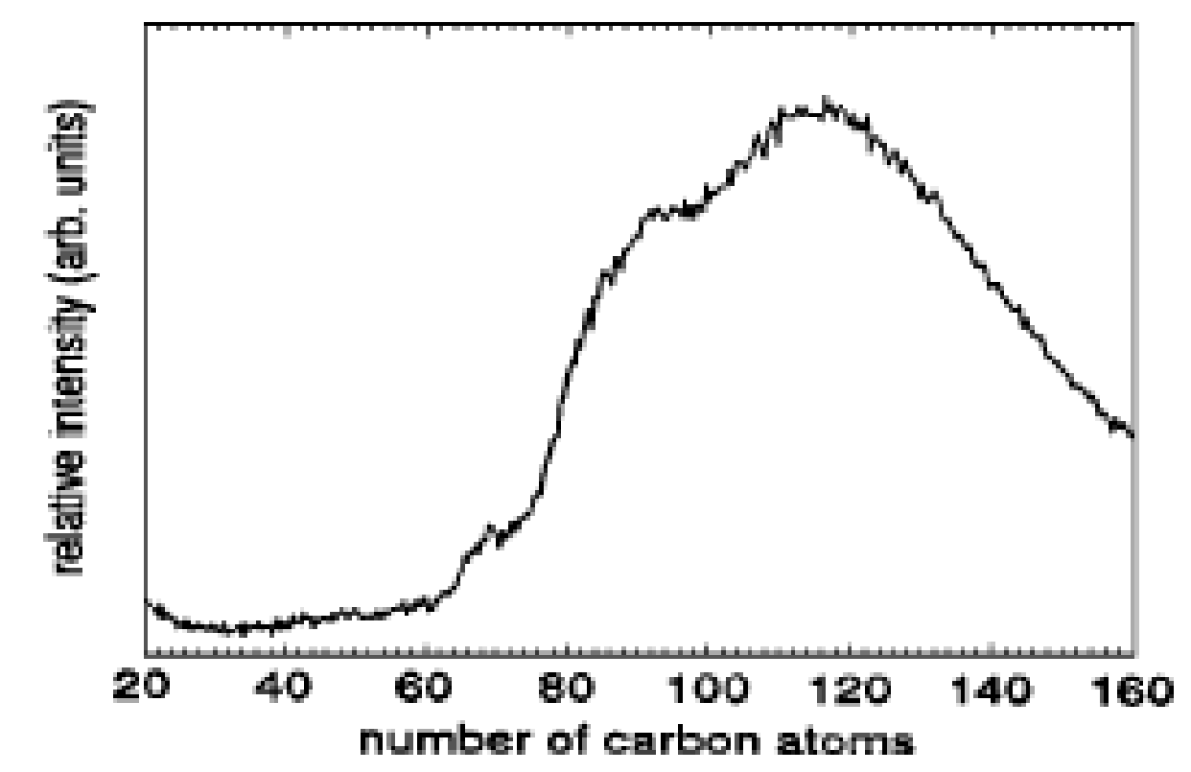 | 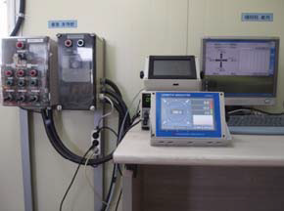
(a) | (b)
FIGURE 1. To format a figure caption, use Microsoft Word template style Figure Caption or Times New Roman 9 pt, centered. The text “FIGURE 1,” which labels the caption, should be bold and in upper case. If figures have more than one part, each part should be labeled (a), (b), etc.

Cite all figures in consecutive order. The word “Figure” should be spelled out if it is the first word of the sentence and abbreviated as “Fig.” elsewhere in the text. If you are writing about a figure, please refer to it by number like this: Fig. (1). Place the figures close to their first mention with the figure caption below, all centered.

Tables
Due to the wide range and complexity of tables, we simply offer an example for guidance. Please follow the style for table captions. Note that the caption appears above the table, unlike figure captions.

TABLE 1. To format a table caption, use template style Table Caption. The text
“TABLE 1,” which labels the caption, should be bold and all letters capitalized. Center this text above the Table. Tables should have top and bottom rules, and a rule separating the column heads from the rest of the table only.

Column Header Goes Here | Column Header Goes Here | Column Header Goes Here
Row Name Here | x | x
Row Name Here | x | x
Row Name Here | x | x

CONCLUSION
Articles should exactly follow this template. Do not change any spacing, formatting, or styles. Please don’t include any headers, footers, or page numbers in your document. Use clear, legible graphics and diagrams, and format references with care. Your paper will need to be submitted as a PDF, which you can create from this file. As the author and creator of your article, you have the most intimate knowledge of exactly what the PDF file should display. We ask all authors to carefully check their article PDF prior to submission. Embed all fonts into your PDF.

ACKNOWLEDGMENTS

Thank you for preparing your article with care!

REFERENCES
References should be numbered in the order they appear using Arabic numerals followed by a period (.), as shown below. Papers, books, and other sources should be formatted as they are below. Journal titles should be listed with their standard ISO4 abbreviation. Article titles are not required. All authors should be listed unless there are more than 10. In that case, list the first 10 followed by “, et. al.” In the examples below, “X” refers to page number.

- A. B. Chavez and D. Edmond, Book Title (Publisher Name, Publisher City, Year), pp. X–X.
- A. B. Chavez and D. Edmond, Abbreviated Journal Title Vol, X-X (Year).
- A. B. Chavez, “Title of Chapter,” in Book Title, edited by D. Edmond (Publisher Name, Publisher City, Year), pp. X–X.
- A. B. Chavez, “PhD thesis title,” Ph.D. thesis, School, Year.
- A. B. Chavez (private communication).

